Q1. The functionality of application layer in X model fits roughly into the top three layers of the OSI model. Draw the Table 1 and answer the item (1) to item (4) in your answer booklet. *(201605 TAR UC, resit)* (2 marks)

|  |  |
| --- | --- |
| OSI model | (4) TCP/IP Model |
| (1) Application Layer | Application layer |
| (2) Presentation Layer |
| (3) Session Layer |

Table 1: Networking Model

Q2. Differentiate the functions of the OSI application layer, presentation layer and session layer.

*(201703 TAR UC, resit)* (12 marks)

|  |  |  |  |
| --- | --- | --- | --- |
| Difference | Application Layer | Presentation Layer | Session Layer |
| Layer | The top layer of both OSI and TCP/IP models | The second layer of OSI layer, not present in TCP/IP model | The third layer of OSI layer, not present in TCP/IP model |
| Function | Provides interface for communication between applications and layers underneath in the network model | Formats, or presents, data from the source device into a compatible form for receipt by the destination device | Creates & maintain dialogues between source & destination applications |
| Purpose | Used to exchange data between programs running on the source & destination hosts | Used to compress, encrypt & decrypt data for transmission | Handles the exchange of information to initiate dialogs, keep them active, and to restart sessions |

Q3. Provide **TWO (2)** applications that are supported by peer-to-peer (P2P).

*(201705 TAR UC, resit)* (3 marks)

* eDonkey
* G2
* BitTorrent
* Bitcoin
* Frostwire

Q4. Differentiate between GET message and POST message. *(201703 TAR UC, resit)* (4 marks)

|  |  |  |
| --- | --- | --- |
| **GET** | **Differences** | **POST** |
| A client request, used to request data. | Usage | Used to send messages that upload data to the web server. |
| Sent by a web browser to request pages from a web server. | Purpose | When the users enters data into a form embedded in the web page, POST includes the data in the message sent to the server. |

Q5. (a) List **ONE (1)** protocol that is used to send e-mail messages. *(201705 TAR UC, resit)*

(1 mark)

Simple Mail Transfer Protocol (SMTP)

1. Provide **TWO (2)** comparisons of Post Office Protocol version 3 (POP3) and Internet Message Access Protocol (IMAP). *(201705 TAR UC, resit)* (4 marks)

|  |  |  |
| --- | --- | --- |
| Differences | Post Office Protocol Version 3 (POP3) | Internet Message Access Protocol (IMAP) |
| Protocol working method | It allows for email messages to be downloaded to the client’s device | The original message reside on the server until manually deleted by user. |
| Centralization of message | There is no centralized location where email messages are kept | Requires a centralized mail server to store e-mail messages |
| TCP port used | Using TCP port 110 | Using TCP port 143 |

1. Briefly explain TWO (2) processes that are handled by e-mail servers.

*(201705 TAR UC, resit)* (4 marks)

Mail Transfer Agent (MTA)

* Governs e-mail handling between servers and servers

Mail Delivery Agent (MDA)

* Delivers e-mail messages to a local recipient’s mailbox.

Q6. With reference to Figure 1, answer the following questions:

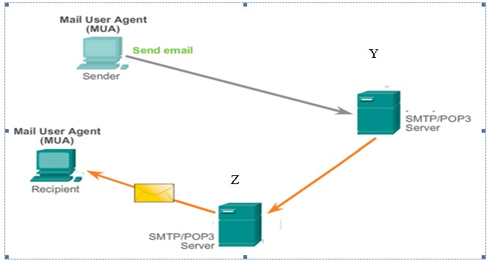

Figure 1: Email Operation

1. Identify the type of mail agents labeled with Y and Z. *(201609 TAR UC, Main)* (3 marks)

Y: Mail Transfer Agent (MTA)

Z: Mail Delivery Agent (MDA)

1. Differentiate between mail agent Y and mail agent Z. *(201609 TAR UC, Main)* (6 marks)

|  |  |
| --- | --- |
| Mail agent Y (Mail Transfer agent) | Mail agent Z (Mail delivery agent) |
| Used to forward e-mail | Accepts email from mail transfer agent (MTA) and perform delivery |
| Receives message from MUA (Mail user agent) or from another MTA on another e-mail server | The MDA receives all the inbound mail from the MTA and place it at appropriate user inboxes |
| Based on the message header, MTA determines how to forward the message to reach its destination | The MDA resolves final delivery issues, such as virus scanning, spam filtering, and return-receipt handling |

Q7. XYZ Company plans to implement a new application in its network that is able to connect the local mail server for sending and receiving daily emails to their clients.

1. What are the **TWO (2)** types of protocols and their respective port numbers that are essential in developing the new application? *(201603 TAR UC, resit)* (4 marks)

Two types of protocols uand its port numbers:

* SMTP uses TCP port 25
* POP3 uses UDP port 110

1. Discuss **THREE (3)** types of mail agents involved in the new application.

*(201603 TAR UC, resit)* (9 marks)

Mail User Agent (MUA)

* Used to compose messages
* Known as an email client
* Allows messages to be sent and received, placing in the client’s mailbox

Mail Transfer Agent (MTA)

* Used to forward e-mail
* Receives messages from MUA or another MTA
* MTA looks in message header to determine how the message must be forwarded to reach the destination

Mail Delivery agent (MDA) (NOTE: Instructor answer missing, check back!)

* Accepts mail from MTA
* Performs the actual delivery
* Place the mail inside inboxes
* Resolve final delivery issues (virus scanning, spam filtering, return-receipt handling)

Q8. (a) Describe how the DNS works by using the destination address: [www.cisco.com.](http://www.cisco.com/)

*(201603 TAR UC, resit)* (8 marks)

- First, a domain name or URL ([www.cisco.com](http://www.cisco.com)) is entered in the address field of the browser. The browser passes the name to the resolver.

- Secondly, the resolver sends the DNS request to the DNS server.

- Thirdly, the server then searches its records and resolves te name with a corresponding IP address

- Lastly, the DNS serveer then sends the IP address back to the client that made the request. The IP address will be used in the encapsulation process as the destination address for packets going to www.cisco.com.

(b) Give any **FOUR (4)** examples of top level domains. *(201603 TAR UC, resit)* (4 marks)

- .au – Australia

- .co – Columbia

- .com – business/industry

- .edu – education field

- .gov – government agency

- .jp – Japan

- .my – Malaysia

- .org – non-profit organization

Q9. The Dynamic Host Configuration Protocol (DHCP) service enables devices on a network to obtain information from a DHCP server.

1. Give **FOUR (4)** examples of the information obtains from a DHCP server.

*(201605 TAR UC, resit)* (2 marks)

* *DNS server’s IP address*
* *Lease expire date and time*
* *Lease obtain date & time*
* *Lease IP Address*

1. With the aid of diagram, illustrate the FOUR (4) steps process of DHCP.

*(201605 TAR UC, resit)* (12 marks)

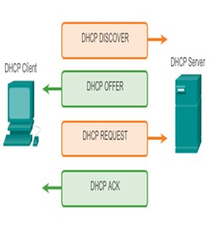

DHCP Discover

* When a DHCP-configured client boots up or connects to the network, the client broadcasts a DHCP DISCOVER packet to identify any available DHCP servers on the network.

DHCP Offer

* DHCP server replies with a DHCP OFFER, which is a lease message with an unassigned IP address, subnet mask, DNS server, and default gateway information as well as the destination of the lease

DHCP Request

* The client can receive multiple DHCP OFFER packets if the local network has more than one DHCP server. The client must choose between them and broadcast a DHCP REQUest packet that identifies the chosenT server and lease ofer that it is accepting.

DHCP Acknowledge

* Assuming that the IP address requested by the client, or offered by the server is still valid, the chosen server would return a DHCP ACK (acknowledgement) message. The ACK message lets the client know that the lease is finalized.

Q10. Briefly explain the main function and state the well-known port number with transport layer protocol used for the following application layer protocols:

1. Hypertext Transfer Protocol (HTTP) *(201703 TAR UC, resit)* (4 marks)

* It is used to transfer files that make up the web pages of the internet
* TCP port 80

1. Domain Name System (DNS) *(201703 TAR UC, resit)* (4 marks)

* It is used to resolve Internet names to IP addresses
* TCP/UDP port 53

1. Dynamic Host Configuration Protocol (DHCP) *(201703 TAR UC, resit)* (4 marks)

* It is used to assign an IP address, subnet mask, default gateway, and DNS server to a host
* UDP port 67